**RESUME**

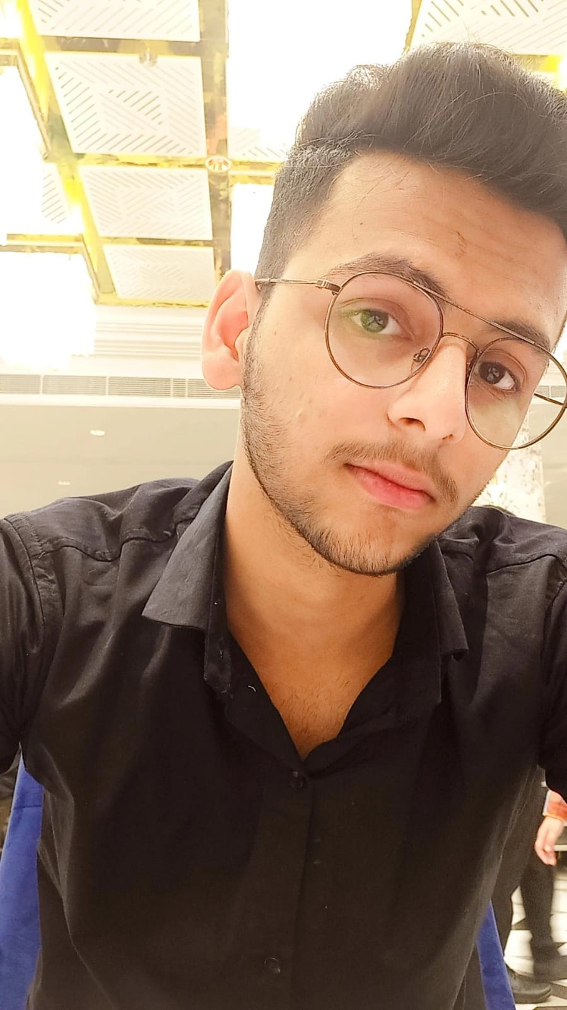

**Name: Priyanshu Mudgal**

**Address: Rajendra Park, House no. B54, Gurugram, Haryana**

**Email ID: Priyanshumudgal175@gmail.com**

**Contact No. 9319710134**

**LinkedIn link: https://www.linkedin.com/in/priyanshu-mudgal-b18217237**

**CAREER OBJECTIVE:**

* To be the part of an enthusiastic work environment, where I can use my technical skills to accomplish organizational goals.
* To run a start-up.

**ACADEMIC BACKGROUND:**

Pursuing B. Tech in **COMPUTER SCIENCE ENGINEERING & TECHNOLOGY** from dronacharya college of Engineering, Gurgaon, Approved by **AICTE**.

|  |  |  |  |
| --- | --- | --- | --- |
| **Institute/University** | **Degree/Examination** | **Percentage** | **Year** |
| Dronacharya college | B. Tech | 84.00% | 2022 |
| Md senior secondary school | 12th | 77.00% | 2021 |
| Vivekanand global school | 10th | 87.00% | 2019 |

**TECHNICAL SKILLS:**

* **Language                :  Basic concepts of C**
* **Operating Systems:  Microsoft Windows XP/VISTA, Windows10**

# CERTIFICATIONS AND MEMBERSHIPS:

* Certification of Clanguage from cousera completed in July2021
* 1st position in mavericks.
* 2nd position in Hack-o-relay.
* 1st position in volleyball.
* NCAT
* 100-meter race
* Sack race

# WORKSHOPS AND TECHNICAL EVENTS:

* Attended one days Drone Workshop at Dronacharya College of Engineering in December 2021.
* Attended two days Web Design workshop at Dronacharya college of Engineering in December 2021.

**ACHIEVEMENTS:**

* Won the 1st prize in technical competition held in mavericks.
* Won 1st prize in volleyball.
* Won 2nd prize in Hack-o-relay.
* NCAT

**STRENGTHS:**

* The ability to Work in a team.
* The ability of being physically strong.
* Hard-working with lots of patience.
* Good concentration.

**EXTRACURRICULAR ACTIVITIES:**

* Web designing.
* BGMI player.
* Volleyball player.